Murph Pair Skate Park and its Condition

In this day and age, skateboarding is having a worldwide increase with new skaters joining the movement everyday. With the introduction of new skateboarders requires new skating facilities for them to use and some previous parks fit these standards. However, the Delford Rieff Park’s small Murph Pair Skate Park(located in Prairie Grove, AR) doesn’t meet up to skateboarding standards. Delford Rieff Park is an area with baseball fields, an aquatic park, and of course a skatepark. Starting off, Murph Pair is poorly designed and skaters wonder why elements of the park were designed the way they were. That’s just the start of it though, I haven’t even mentioned the condition the park is in and how it’s treated.

Let’s begin with the condition of Murph Pair Park. Walking up to the skatepark initially you start to think, “Wow what a nice looking park!” But on closer examination, you will begin to realize how poorly treated this park really is. The skatepark has a rampant littering problem with everything from empty Gatorade bottles to full Sonic drinks and sometimes even empty packs of cigarettes. These items sometimes are just dumped on the park’s ground and are usually found behind the ramps of the park. Littering wouldn’t be a big problem if the city actually came by and emptied the trash can every once in a while. I’ve only seen the trash can at Murph Park emptied once in the past 4 months. Beginning at the end of August to the middle of January. The trash can fills up to the brim and all of the disgusting waste overflows onto the earth.

Even with the rampant littering problem, there are still even more things wrong with the park’s condition. The park has been vandalized several times now. Several kids spray painted the ramps with derogatory terms and inappropriate images. And the fence that runs along the skatepark(shown in the picture below) has fallen down. No idea whether the fence fell with time or it was deliberately destroyed.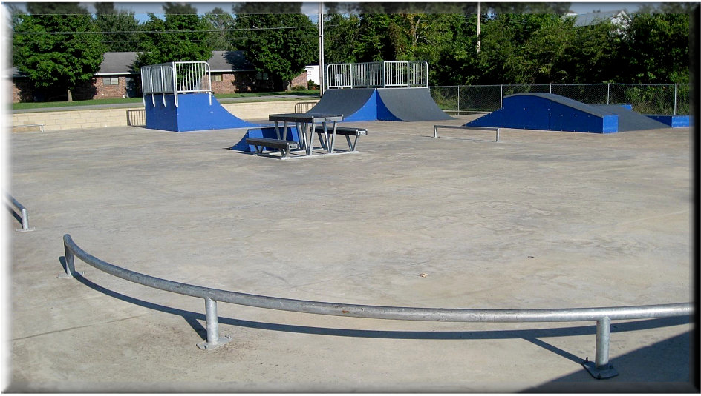

Now onto the park’s design in regard to a skateboarders perspective. This sort of “jump box” at the left side(right side of picture) of the park has a stair set connected for skaters to jump off of. It also has a rail for people to grind down. The only problem with the jump box is the elevation of it. It’s just too steep for anybody to get enough speed naturally to jump off of. There is a very tall ramp(not shown) beside this jump box that connects the two if you ride off this tall ramp. If someone was to ride off the tall ramp, they would have enough speed, but that’s the only way for someone to do it. There is just too much flat ground space for skaters.

Also, maybe fix the lights too. There are supposed to be 2 lights that would light up the park at night, but only one works. Or, only one is supposed to work, but that wouldn’t make sense since only 1/4 of the park is really lit up well. The timing on the light is fine considering curfew is 9 P.M. on weekdays anyways...

I almost forgot, there are a series of rails on the outer perimeter of the park. You might be thinking this is great, however, the rails are placed really close to the concrete wall that surrounds the park. This is okay, but they are still hazardous. Let’s say a person went to rail slide and accidentally falls, hitting the wall. That wouldn’t be the nicest thing to happen. I may sound like a parent complaining to the manager of a restaurant, but be lenient with me on this one. I’ve seen people almost hit the concrete wall and I personally almost fell on it. I don't strive to do so either.

Solutions to Murph Pair Skate Park are rather simple and wouldn’t require a lot of money from the city. Adding more fun box or jump box type ramps, different elevation preferably. Also, adding an actually manny pad to the park would be really nice. I think the manual pad would open up a new possibility for skaters to trick, myself included. Finally, move a couple rails from beside the wall and it would be close to perfection it can get for how small it is. Even replacing rails with elements would be better.